

# MUSE SPACE SHOOTER

By Alexander Man | 300792470

All work Copyright © By Epic Logo Company

All Rights Reserved.

Table Of Contents

Detailed Game Description

Controls

Sketches

Screenshots

Characters

Scoring

Sound Index

Version History

Art Reference

# Detailed game description

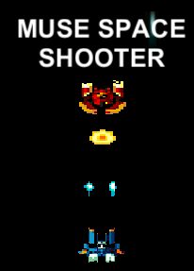

Muse Space Shooter is a 2d space shooter game made with Unity 5. This game was inspired by Unity’s original space shooter tutorial but this game is more arcade retrospective in the sense of lighting, sprites and movement. The game takes place in outer space where one pilot alone must defend themselves from the perils of space, which is the red fleet. Wandering in unknown territory, you, the player must avoid enemy fire and ship collisions as the red fleet attempts to ruin your day. Can you survive the fleet? Go try now!

# CONTROLS

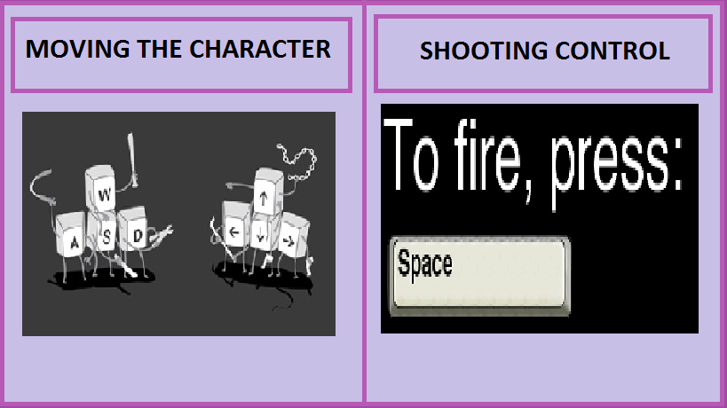

# Sketches

|  |
| --- |
| Fig 1: Sketch of interface |
| Fig2: Sketch of game |
| Fig3: Sketch of fire |
| Fig 4: Sketch of background |
| Fig 5: Characters |

# Screenshots

|  |
| --- |
| Fig 1. Game Menu |
| Fig 2: Initial game |
| Fig 3: Enemy unit is in sight and firing at player |
| Fig 4: Player Firing at enemy |

# Characters

|  |  |
| --- | --- |
|  |  |
| __________________  **Player, The Blue Pilot.**  A wandering space pilot whom dreams of seeing the stars. Little did you know, the Red Fleet was waiting for you, frightening right? Now you must muster your courage to survive the onslaught and defeat as many red pilots as you can. | __________________  **Red Fleet Army, The Red Pilot.**  Trained in advanced piloting, and shooting, the Red Fleet is not to be reckoned with. Hostile and territorial, they will defend their space with all they can, even costing their lives if they must. Avoid colliding with these ships and avoid their bullet fire because they will destroy your ship. |

# Scoring

|  |
| --- |
|  |
| In order to score points your ship must deal damage to the enemy ships. You will gain 100 score points for any damage you deal to the enemy ships. This includes your bullet fire on impact with enemy ships and your collision of your ship and the enemy’s. |

# Sound Index

|  |  |
| --- | --- |
| Sound Name | Source |
| 08_Hysteria | Muse |
| Laser_Shoot16.wav | Vorbis |

# Version History

|  |  |
| --- | --- |
| Version Number | Description |
| V1.0.0.D | Project setup |
| V1.1.0.D | Player ship, scripts |
| V1.2.0.D | Prefabs, enemy, bullet fires |
| V1.3.0.A | Alpha test build |
| V1.4.0.A | Sounds, code edits, minimal changes |
| V1.5.0.A | Background added |
| V1.6.0.B | Stable Beta build |

**INDEX**

V1 = main patch

V1.X = update

V1.X.x = minimal changes

D = development version (not exactly playable)

A = alpha version (playable, some functions still missing)

B = beta version (playable with all functions loaded)

# Art Reference

All character sprites are created by Vorbis Entertainment

08_Hysteria.MP3 by Muse

Laser_Shoot16.WAV by Vorbis Entertainment

Certain fonts by Unity

Score, Lives, Play, Play Highlighted buttons and sprites are created by Vorbis Entertainment.

Background image (bg.png) by NASA